University of Engineering and Technology Taxila Department of Computer Science

PF PROJECT

PACMANN

Developers;

Sohail Asghar 19-CS-18

Hamad Qadir 20-CS-51

Zain Ali 20-CS-65

Muhammad Bilal Gul 20-CS-1

Playing Environments ;

1. Console
2. Graphics

Game Description;

The shows up an arcade or arena within which you have to play the game. The arena has a rectangular boundary in it consisting or capital ‘O’ letters in it. There are obstacles in addition to the boundary wall inn the arrena. None of the characters can pass through any of these obstacles or the boundary but they can touch it.

Characters;

There are basically two type of characteristics and four moving entities on the game console in total.one id the pacman or the user controlled character itself and three are the ghosts or the enemies or the things moving on their own.

***Pacman;-*** the pacman character consists of the second ascii character in the shape of an shaded emoji in the console type game. While in the graphics game due to the lack of such character in normal encoding you have to move around in the form of a capital ‘X’. this pacman can be moved around using the arrow keys on the keyboard.

***Ghosts;-*** these are totally three in number and move using the algorathim. In the consolethey are represented by the ASCII character 1 and in the graphics mode they are simply the alphabet ‘W’.They move own their own and all three have different speed of movement. Their movement is simply in the direction of the pacman till stopped by hurdle. Whenever they move they leave behind a biscuit or prize at that place. These biscuits don’t acta as hurdles.

**Game Objective**

The objective of this game is to make as much score as possible. You get one score when you acquire one biscuit or the prize entity left behind by the ghosts and while doing this you have to avoid the ghost. If the position of the ghost and the Pacman becomes similar the game is over there. The ghost only moves when it can move towards the Pacman so your objective is to first lure in the ghost towards you providing you with enough biscuits and then to acquire those biscuits without getting caught by the ghosts.

Game console;

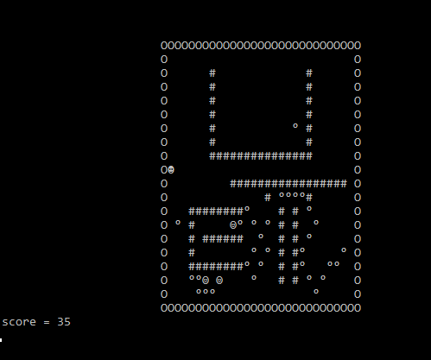

Game graphics:

